Indian E-commerce Pricing & Revenue Dashboard using Power BI

Project Objective
The objective of this project is to analyze Indian e-commerce sales data using Microsoft Power BI. The dashboard helps visualize revenue, customer demographics, product performance, sales trends, discounts, and market competition. It enables users to make data-driven business decisions through interactive reports and visualizations.

Dataset Information
- Dataset Name: Indian E-Commerce Pricing & Revenue Growth
- Dataset Format: CSV
- Total Records: 30,600
- Total Columns: 15

Dataset Columns
- Order ID
- Order Date
- State
- Zone
- Category
- Brand Type
- Customer Gender
- Customer Age
- Base Price
- Discount Percent
- Final Price
- Units Sold
- Revenue
- Sales Event
- Competition Intensity

Software Used
- Microsoft Power BI Desktop
- Power Query Editor
- DAX (Data Analysis Expressions)
- Microsoft Word

5. Data Cleaning
The dataset was imported into Power BI and checked for data quality.
The following validations were performed:
- Missing values check
- Duplicate check
- Error check
- Data type verification
- Distinct value analysis
- Minimum, Maximum and Average value analysis
No missing values or errors were found in the dataset.

DAX Measures Created
The following DAX measures were created:
Total Revenue:
Total Revenue = SUM('indian_ecommerce_pricing_revenue_growth_36_months csv'[revenue])
Total Units Sold:
Total Units Sold = SUM('indian_ecommerce_pricing_revenue_growth_36_months csv'[units_sold])
Average Customer Age:
Average Customer Age = AVERAGE('indian_ecommerce_pricing_revenue_growth_36_months csv'[customer_age])

Average Discount % :
Average Discount % = AVERAGE('indian_ecommerce_pricing_revenue_growth_36_months csv'[discount_percent])
Total Orders :
Total Orders = COUNT('indian_ecommerce_pricing_revenue_growth_36_months csv'[order_id])

Dashboard Overview
The dashboard consists of two pages.

Dashboard Page 1

KPI Cards
- Total Revenue
- Total Units Sold
- Average Customer Age
- Average Discount %
- Total Orders

Charts
- Revenue by State (Bar Chart)
- Revenue by Category (Column Chart)
- Revenue by Brand Type (Pie Chart)

Interactive Filters
- Sales Event
- Category
- State

Dashboard Page 2

Charts
- Revenue by Competition Intensity
- Revenue by Sales Event (Donut Chart)
- Revenue Trend by Year (Line Chart)
KPI | Value
Total Revenue | ₹2.17 Billion
Total Units Sold | 970K
Average Customer Age | 35.57 Years
Average Discount | 38.11%
Total Orders | 31K

Business Insights

Insight 1 – Revenue by Category
The Premium Lifestyle category generated the highest revenue, indicating strong customer demand for premium lifestyle products.

Insight 2 – Revenue by State
Delhi NCR emerged as the top revenue-generating state, followed closely by Karnataka and Maharashtra. Kerala and Gujarat showed similar revenue performance. This suggests that the company has a strong customer base in these regions and should continue targeted marketing and inventory planning to maintain growth.

Insight 3 – Revenue by Brand Type
Mass brands generated the highest revenue, indicating that customers prefer affordable products over premium products.

Insight 4 – Revenue by Competition Intensity
The Medium competition intensity level generated the highest revenue, indicating that the company performs best in markets with moderate competition.

Insight 5 – Revenue by Sales Event
Normal sales events generated higher revenue than Festival sales events, indicating that the business earns a significant portion of its revenue throughout the year rather than relying only on promotional periods.

Insight 6 – Revenue Trend
Revenue showed a steady upward trend from 2023 to 2025, indicating continuous business growth and improved sales performance over the three-year period.

10. Features of the Dashboard
- Interactive dashboard
- KPI cards
- Dynamic slicers
- Bar chart
- Column chart
- Pie chart
- Donut chart
- Line chart
- Drill-down functionality
- Data filtering
- Business insights

Conclusion
This project demonstrates how Microsoft Power BI can be used to transform raw e-commerce data into meaningful business insights. The interactive dashboard provides a clear overview of sales performance, customer behavior, revenue trends, product categories, and market competition. The findings can support business decisions related to pricing strategies, inventory management, regional sales planning, and promotional activities. Overall, the project highlights the importance of data visualization in improving business performance and decision-making.

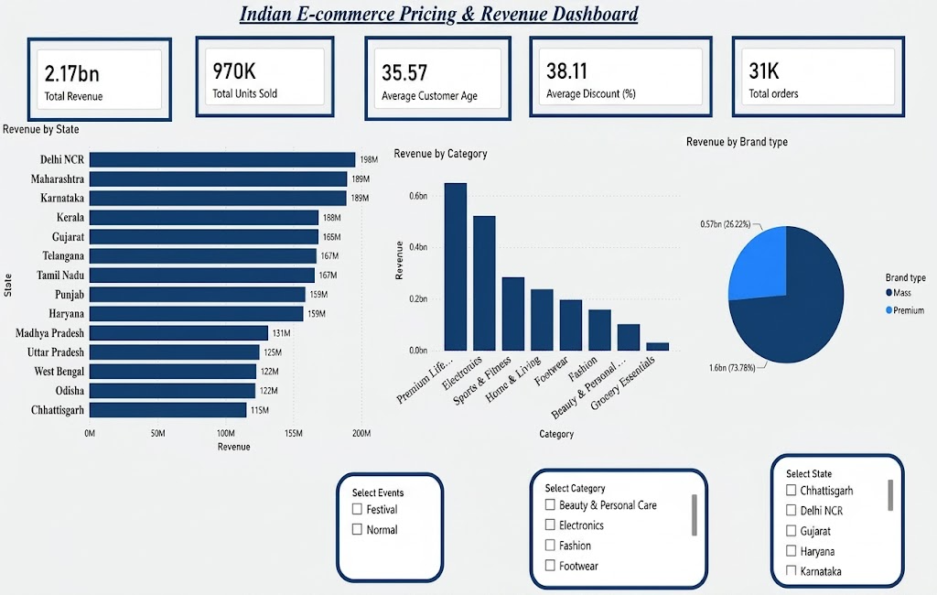
Figure 1 :Overview Dashboard
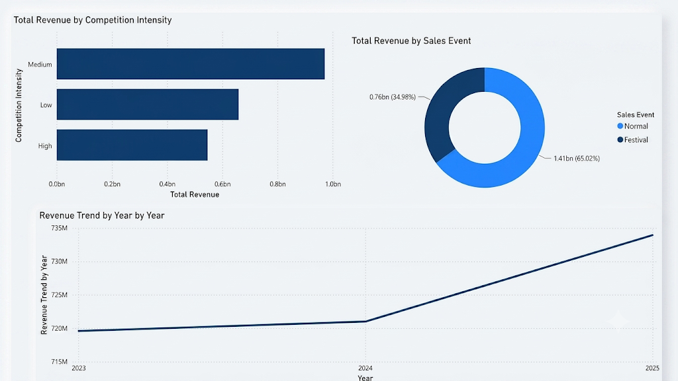
Figure 2:Trend & Analysis Dashboard

